Step1:Create two linux instances,Use the first free linux AMI

ss1:instances list

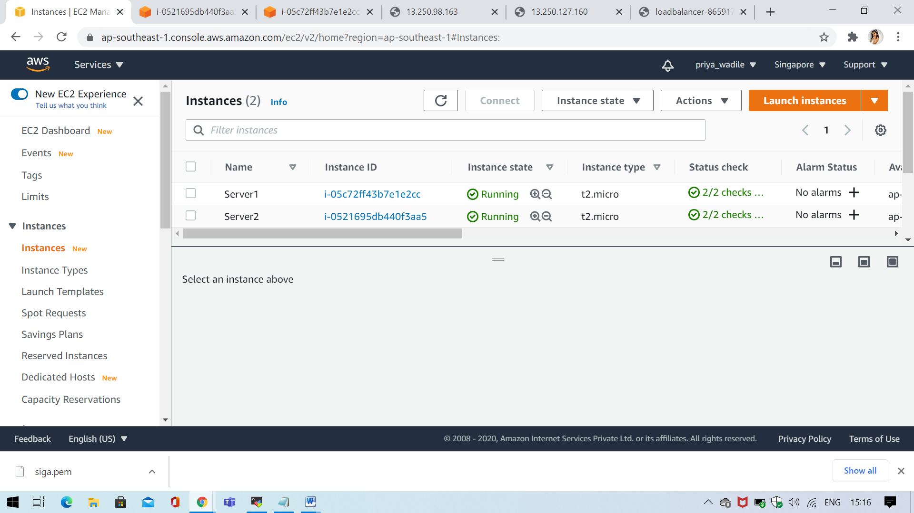

ss2:select a instance and display instance details of server1

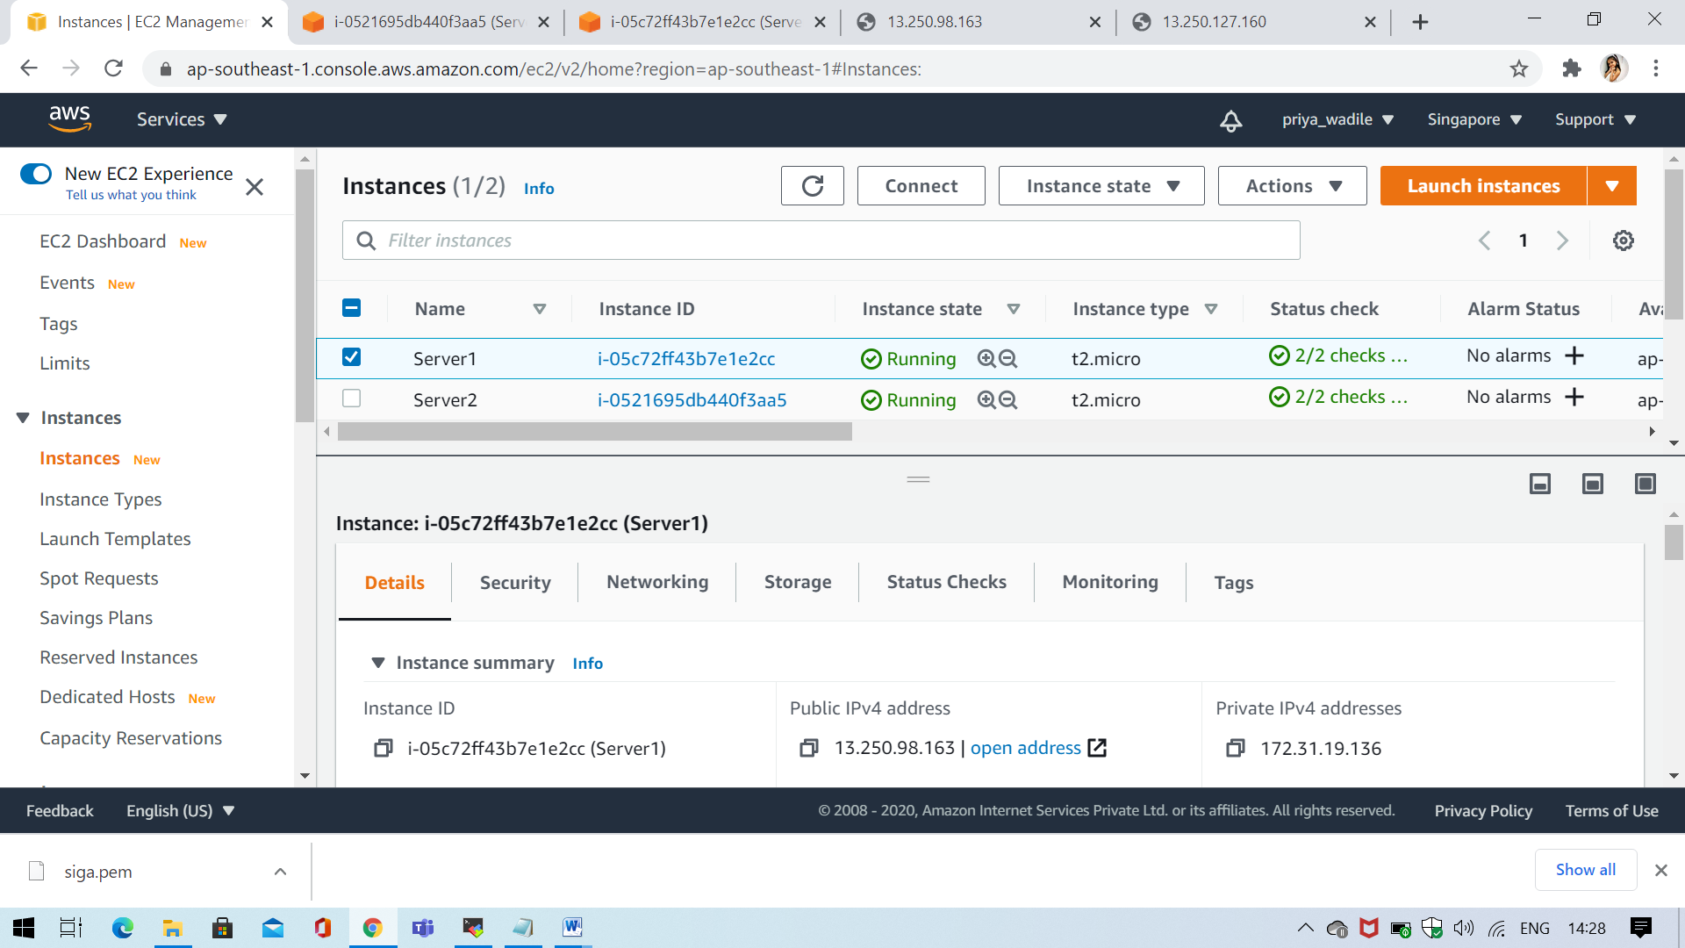

ss3:select a instance and display instance details of server2

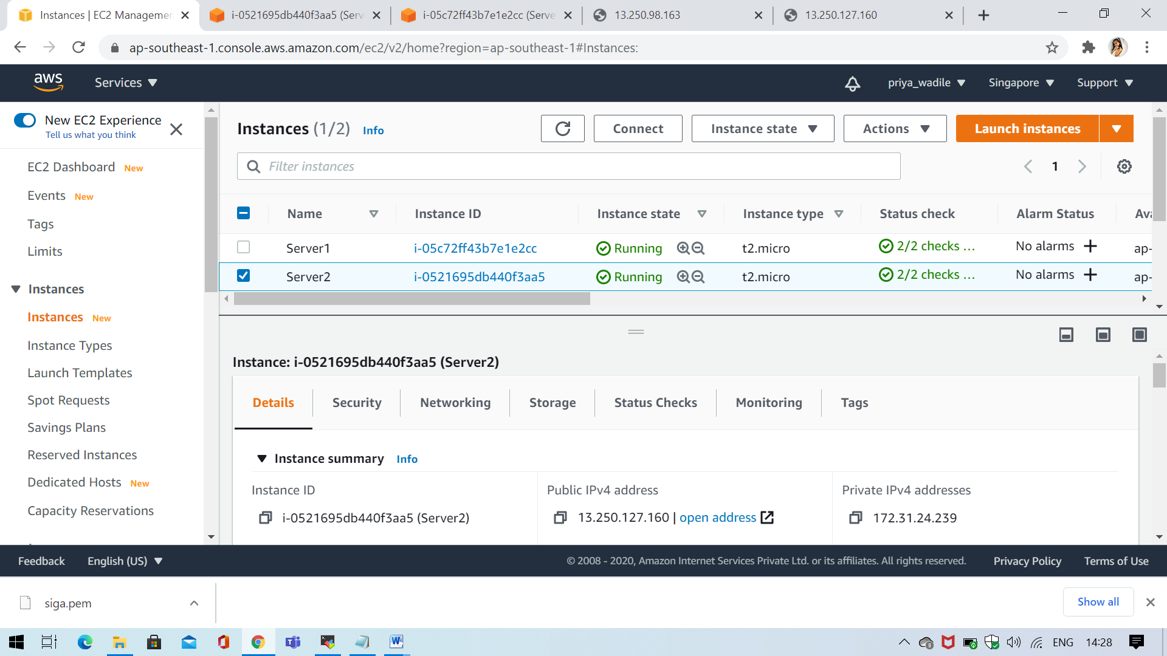

Step2:Launch both instances using Mobaxterm

Step3:Host html login webpage on both servers

ss4:Status: Active running- black screen

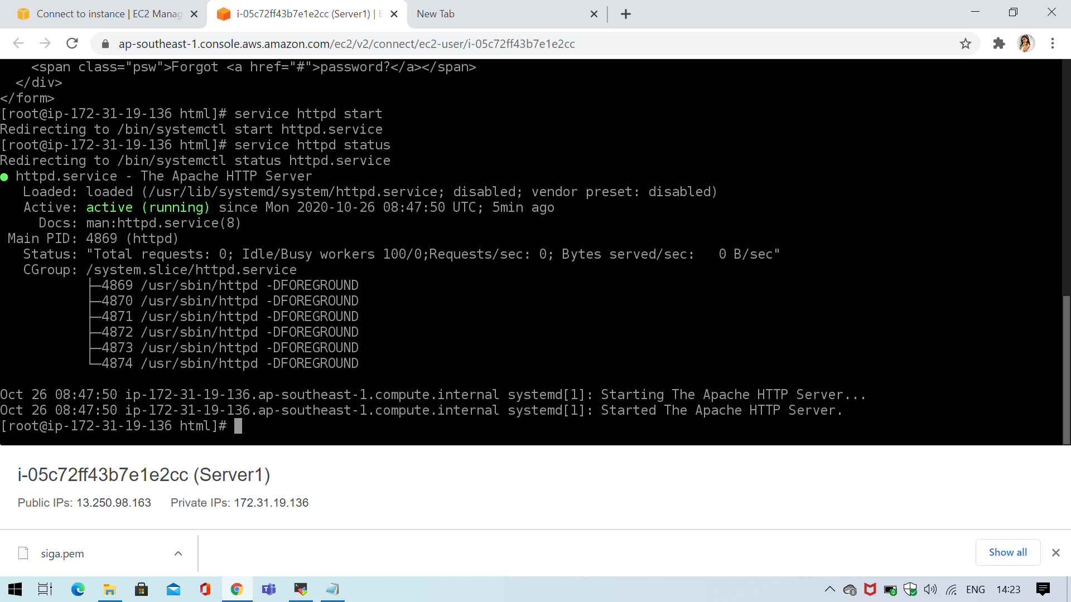

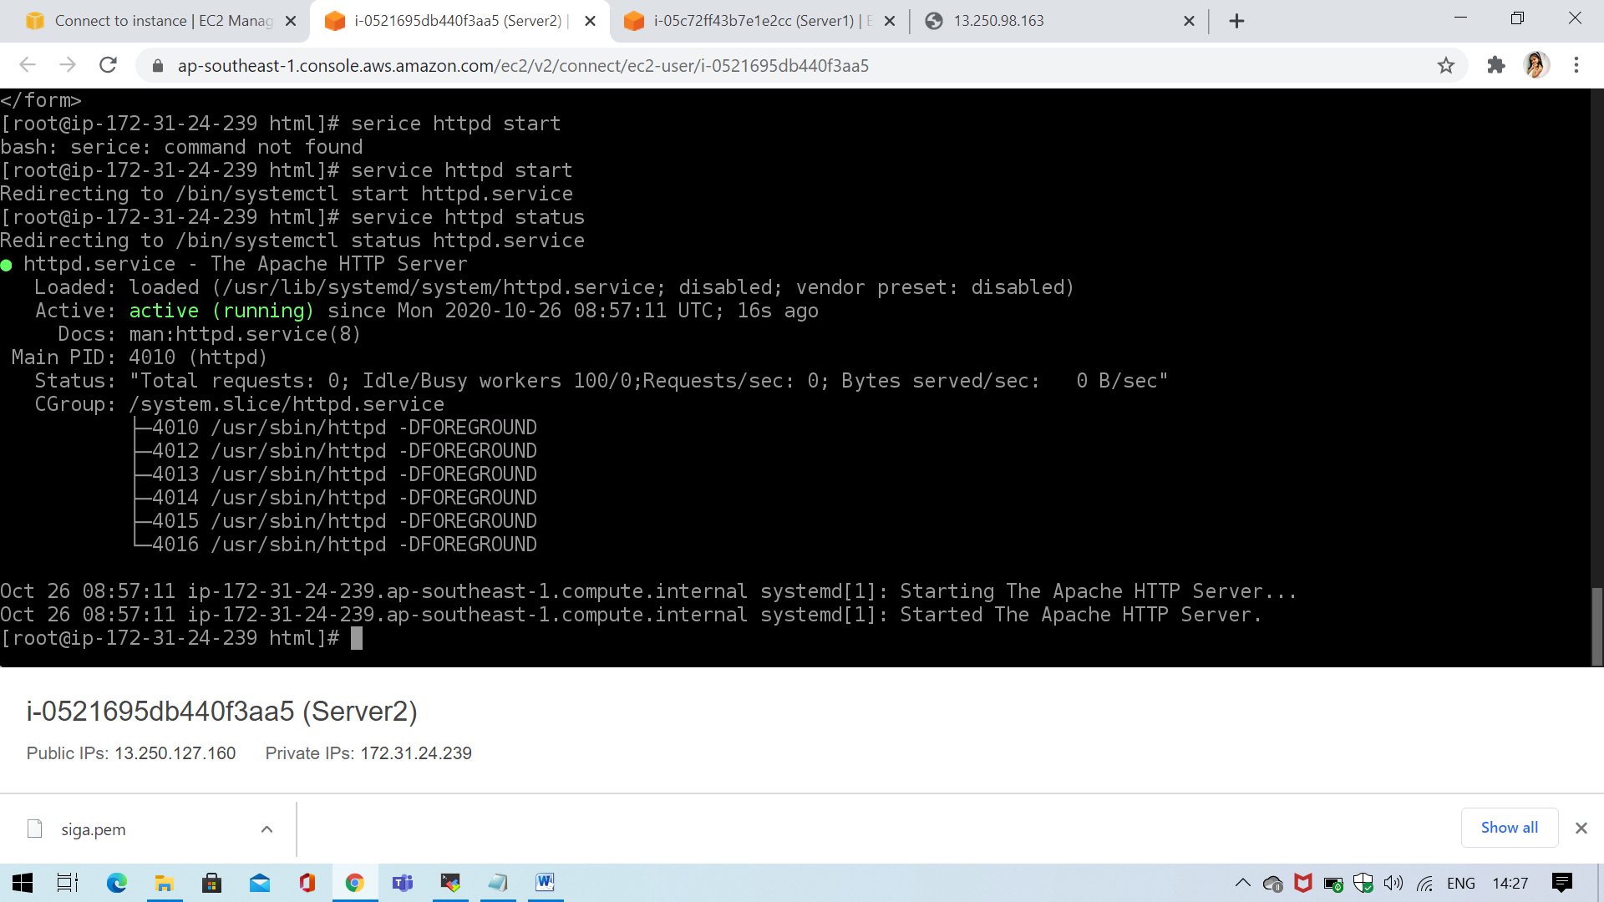

Step4:Check if application is deployed on both servers by copy pasting the public ip of the servers into the browser.

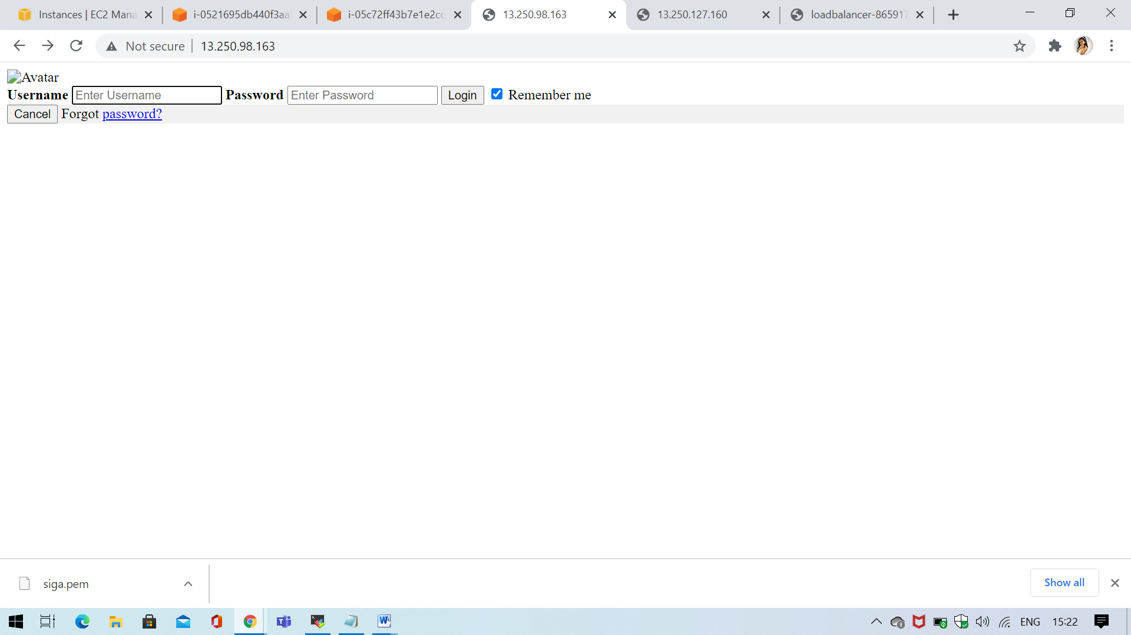



Step5:Create a application Load balancer with the above two instances as targets

ss7:Load balancer screenshot

Step6:Check the functioning of ELB using the DNS of the ELB use the dns

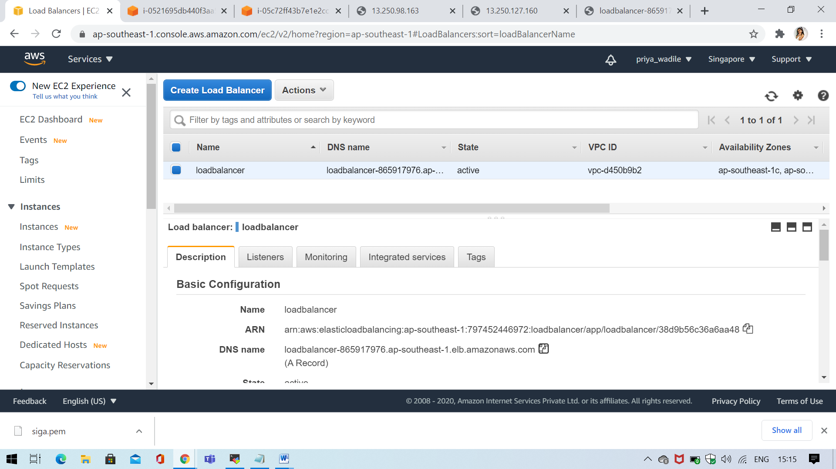

dns ss8:reply from server1

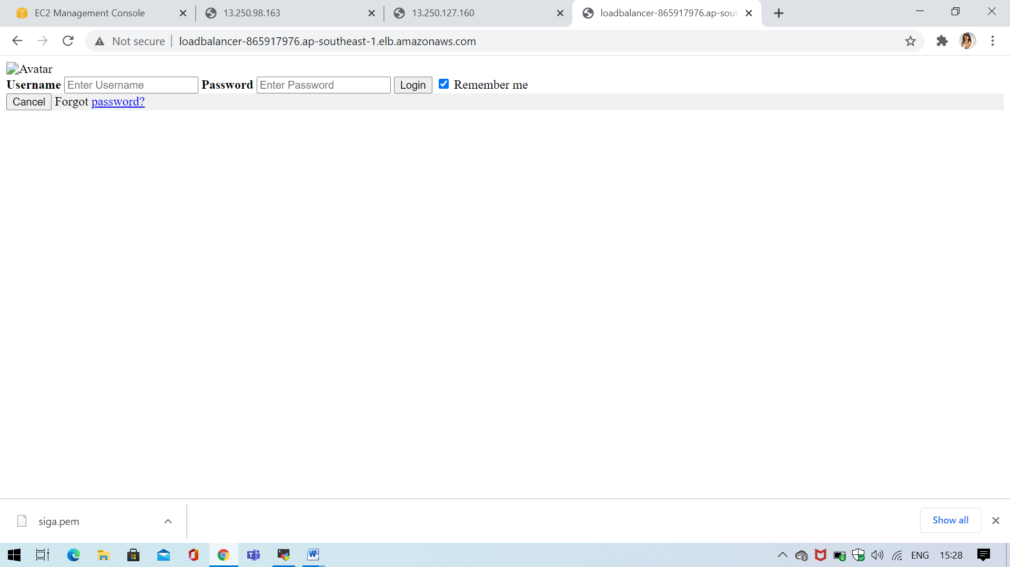

ss9:reply from server2

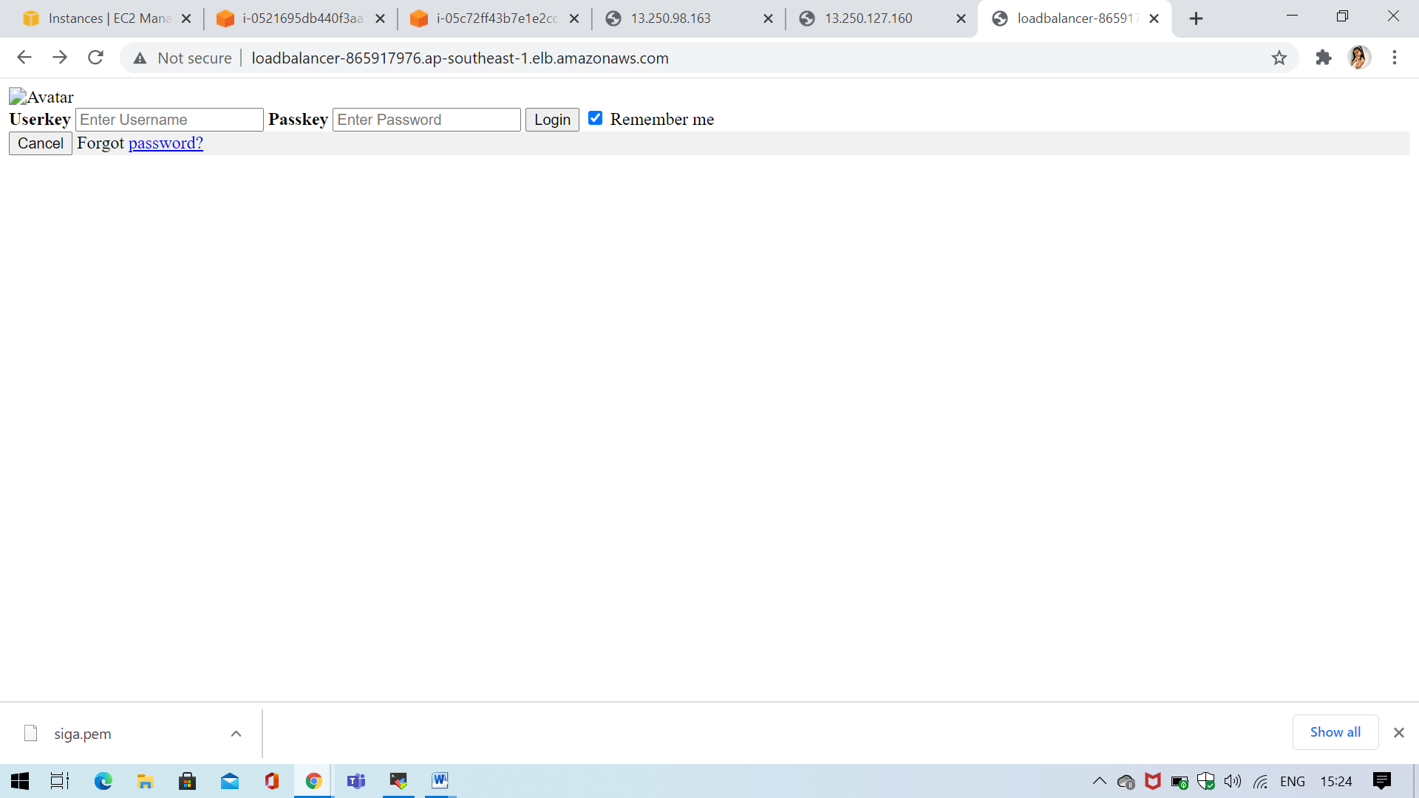

Creating a User Pool in AWS Cognito

Step1 : create user pool

Ss1: Name and Attributes

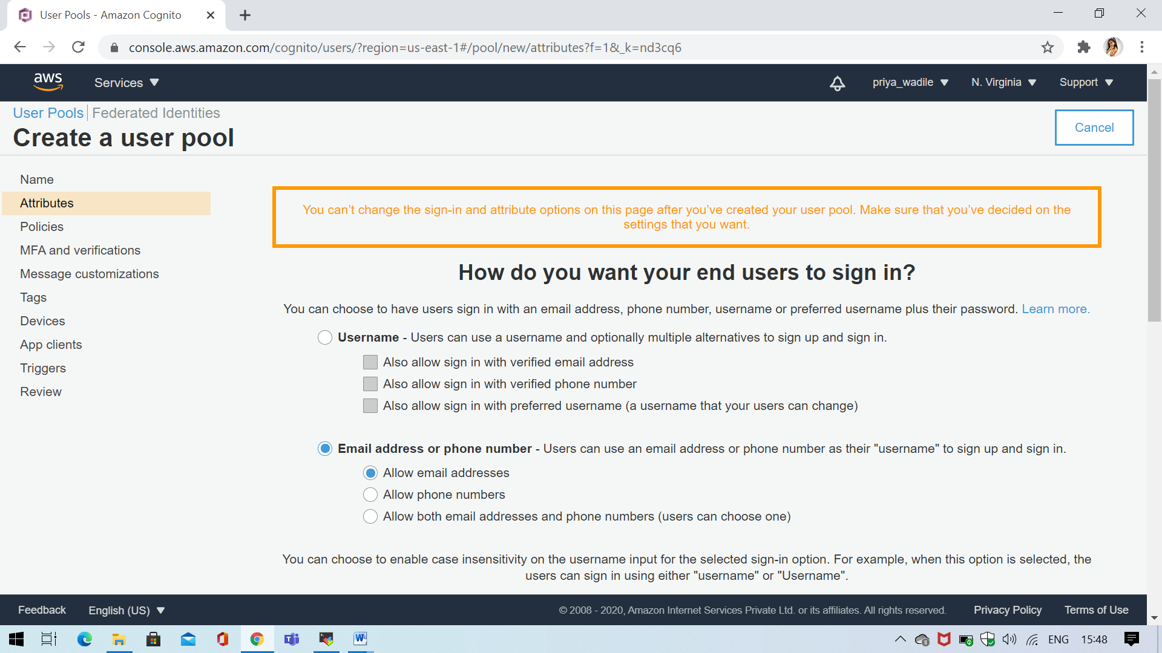

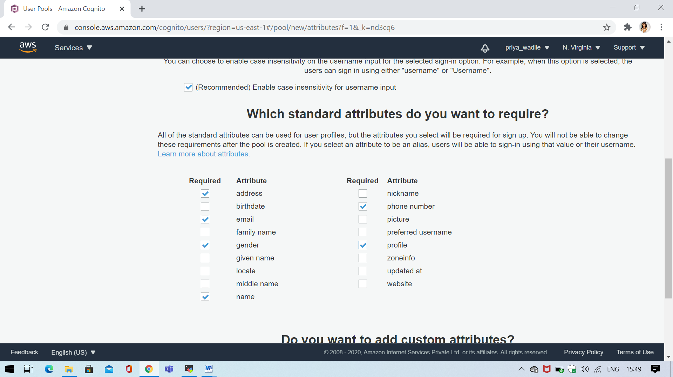

Ss2: Policies

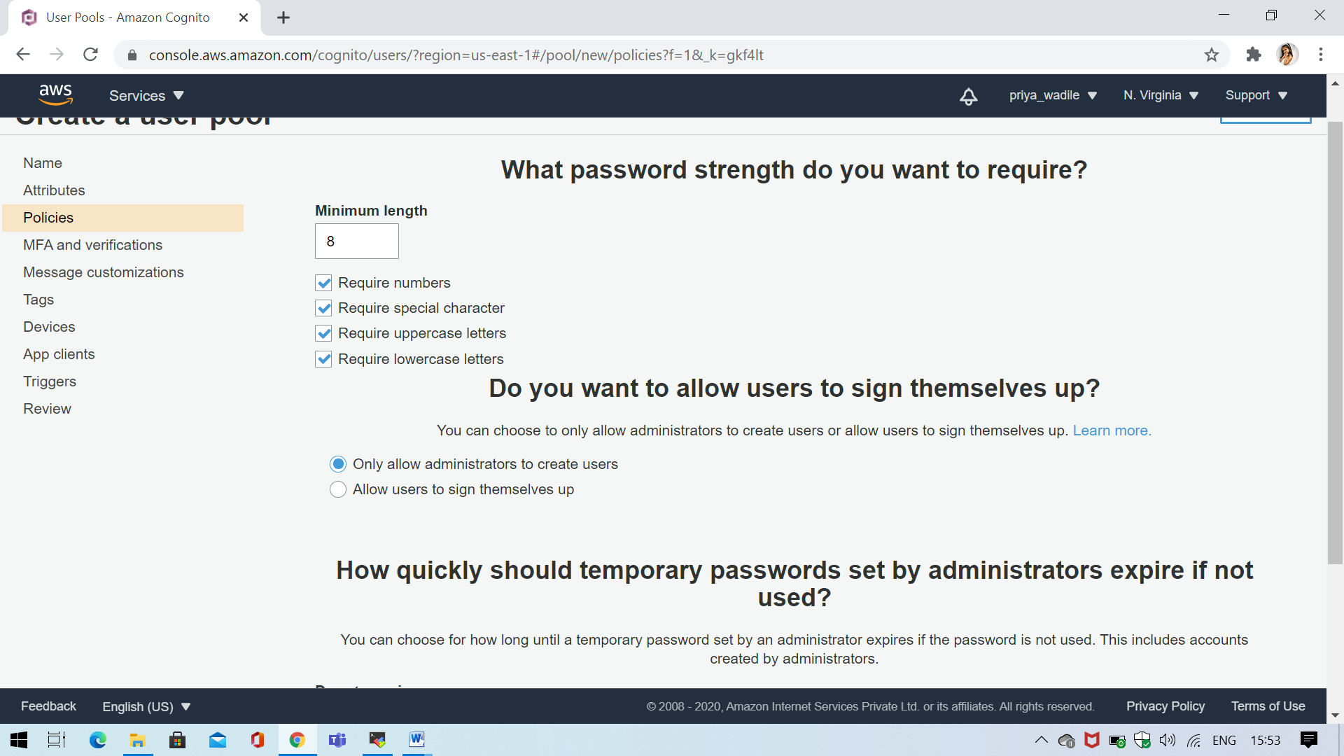

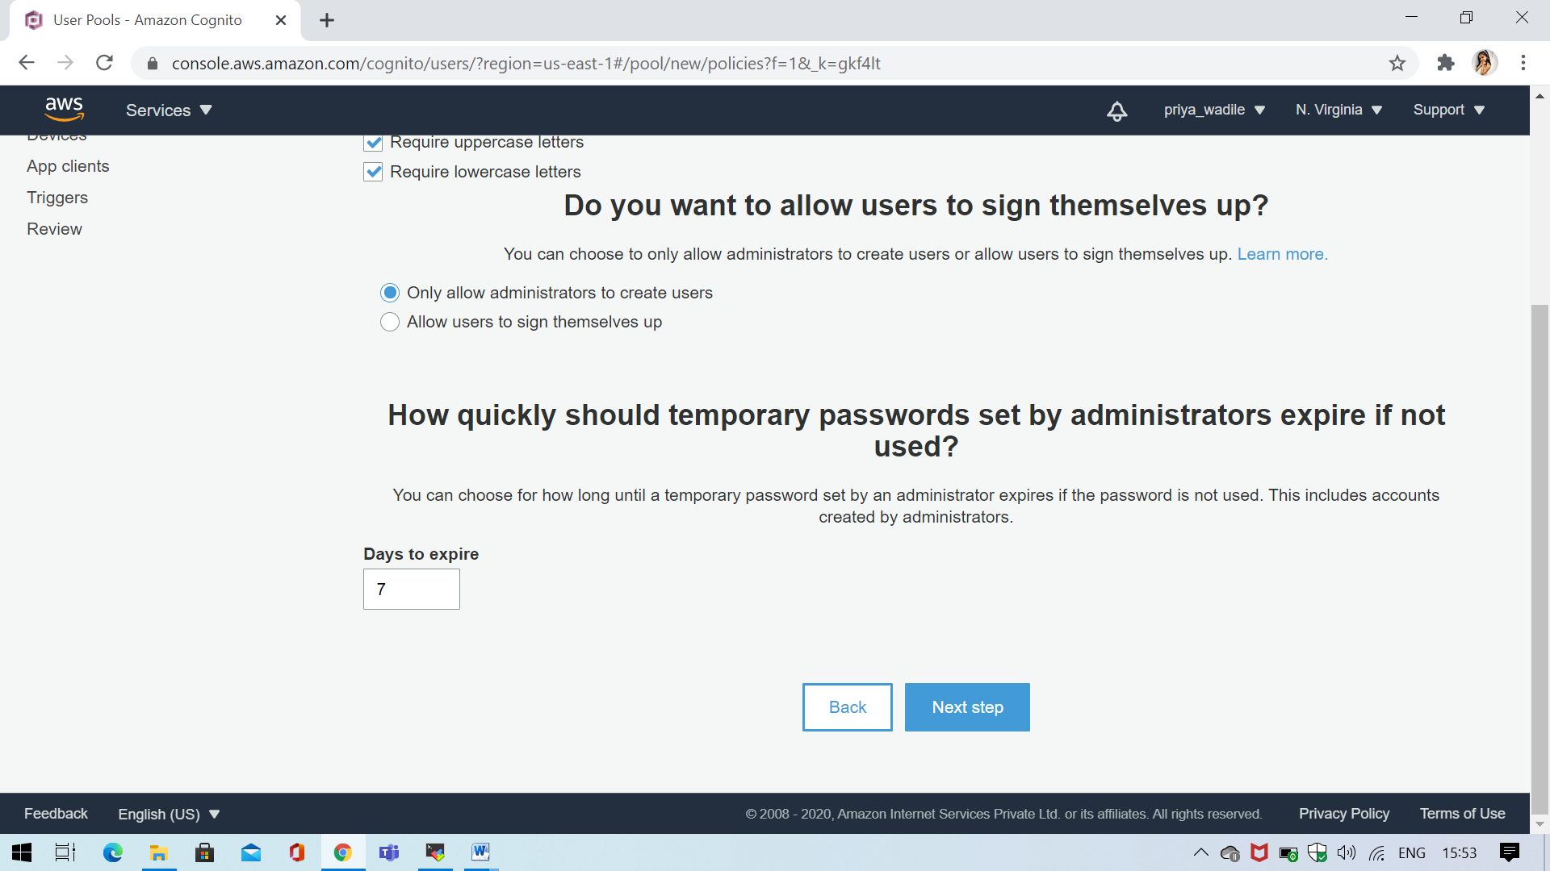

Ss3: Policies MFA and verification

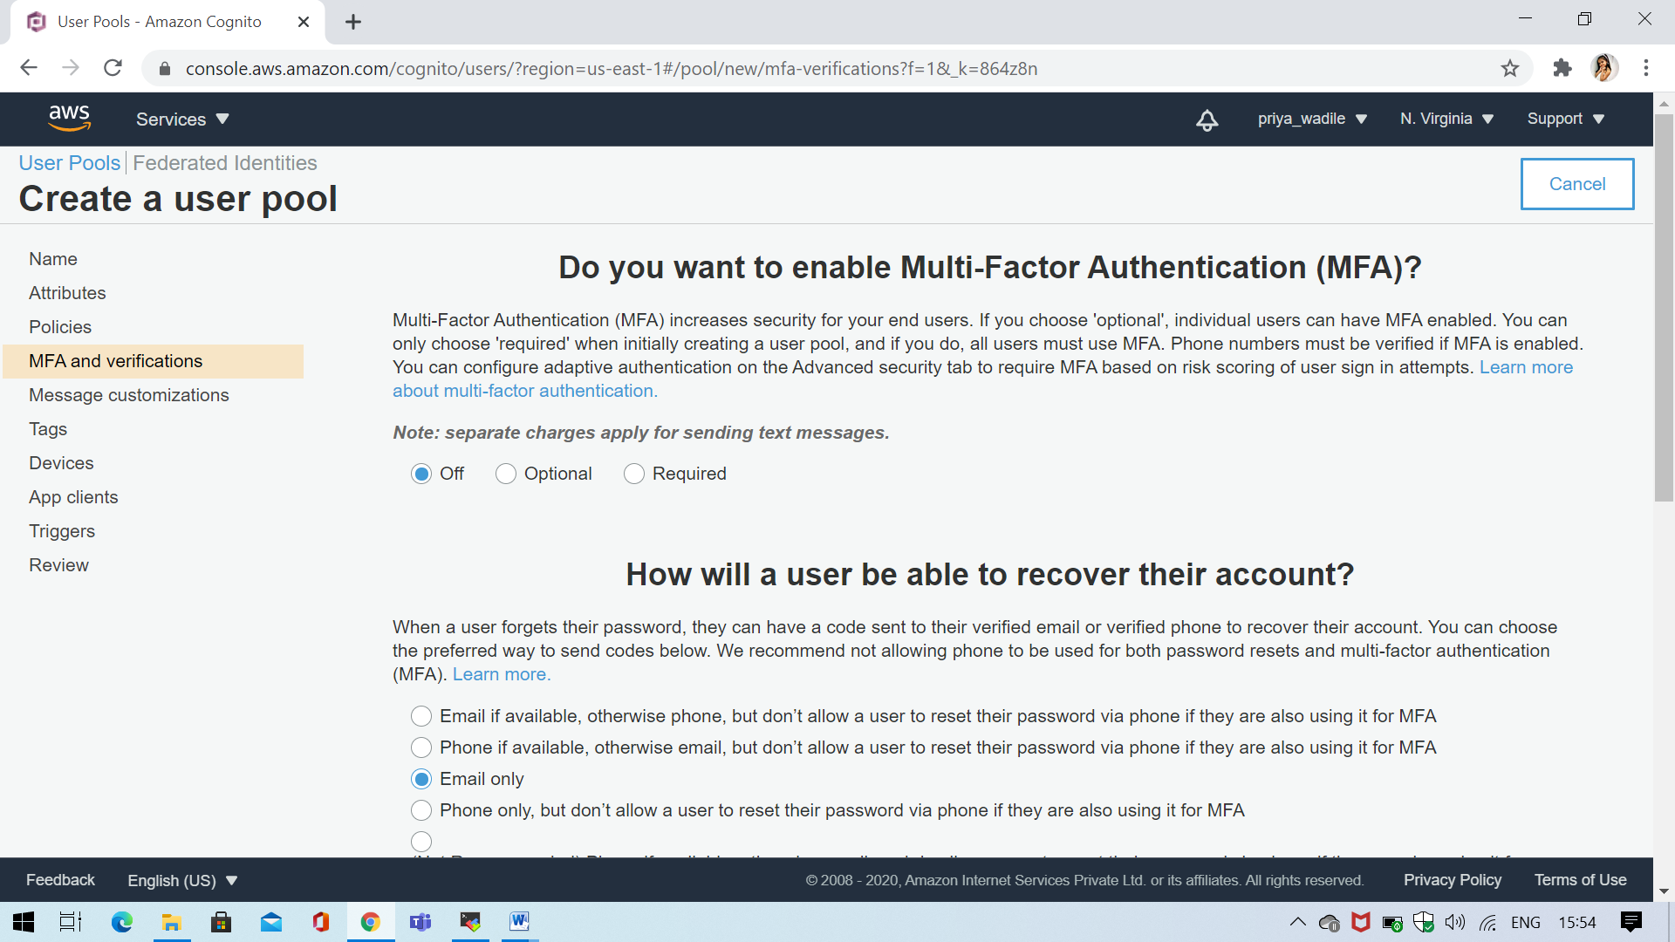

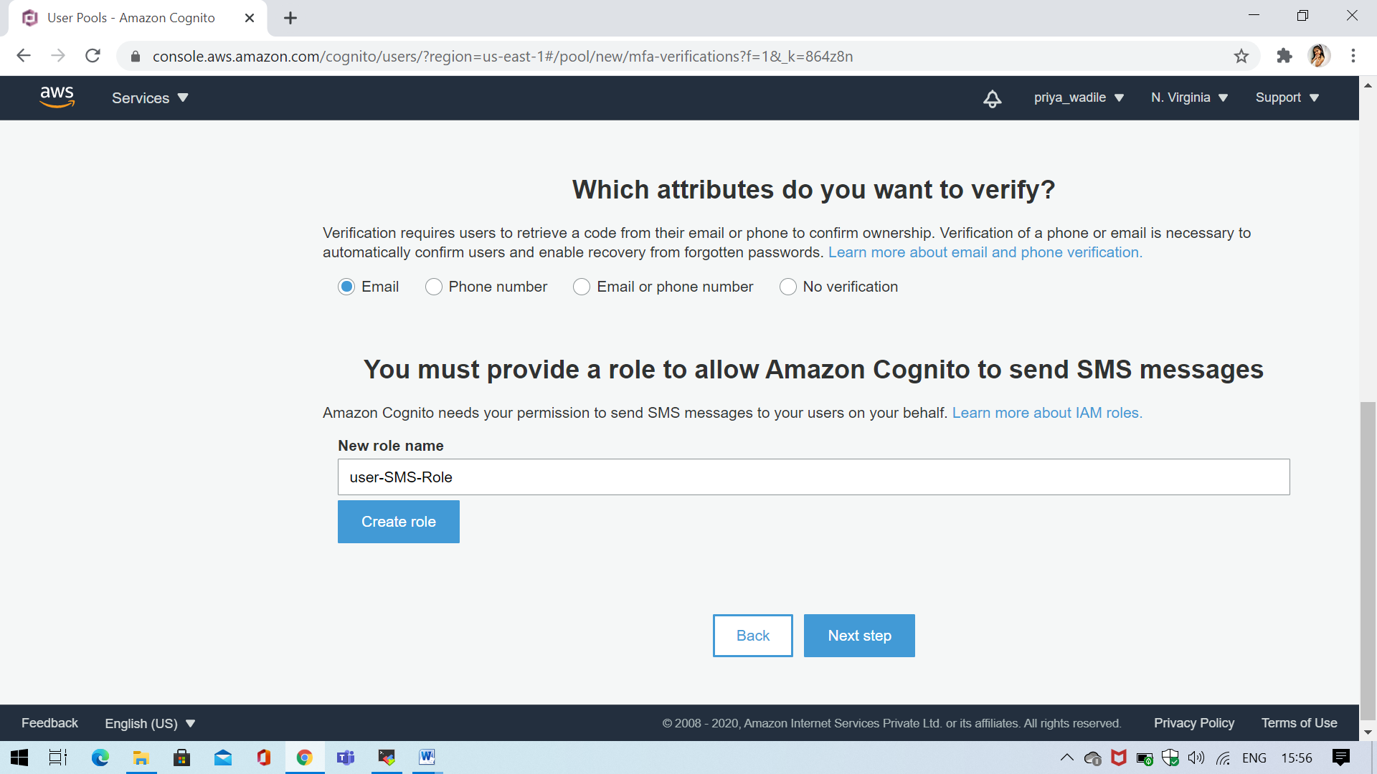

Ss4: Tags

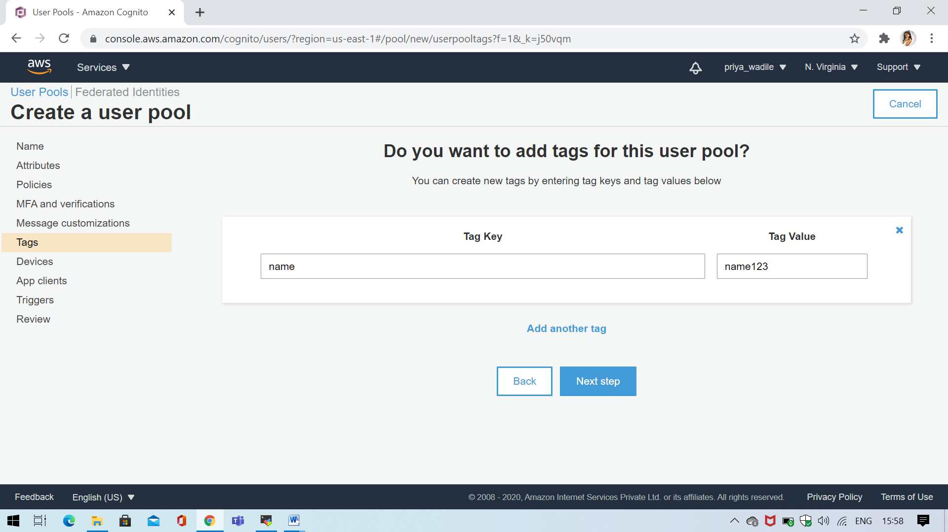

Ss5: Devices

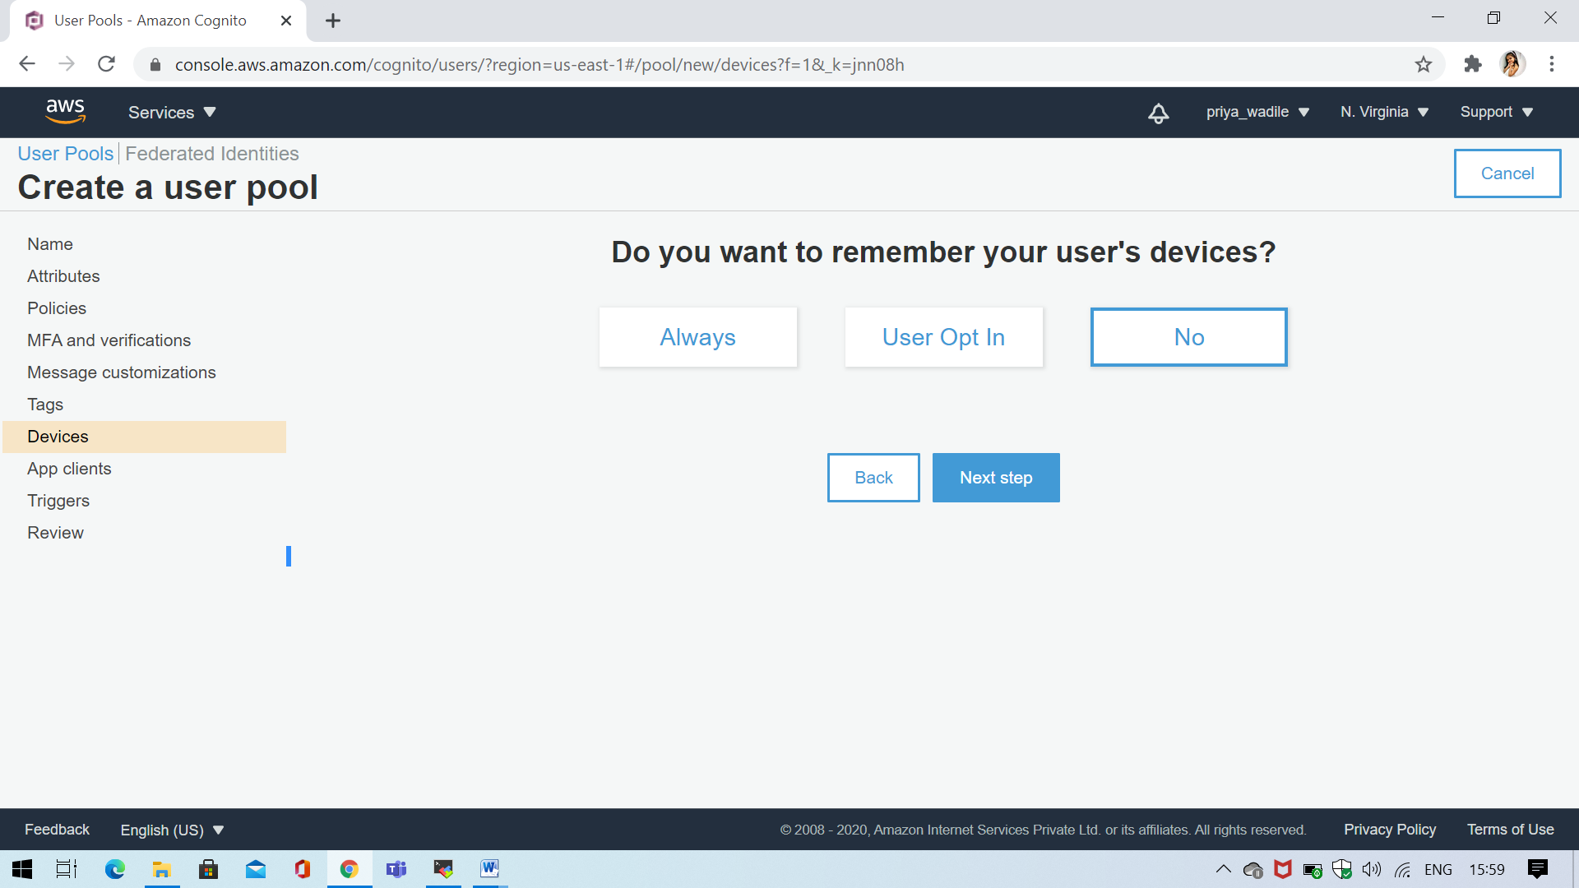

Ss6: Review

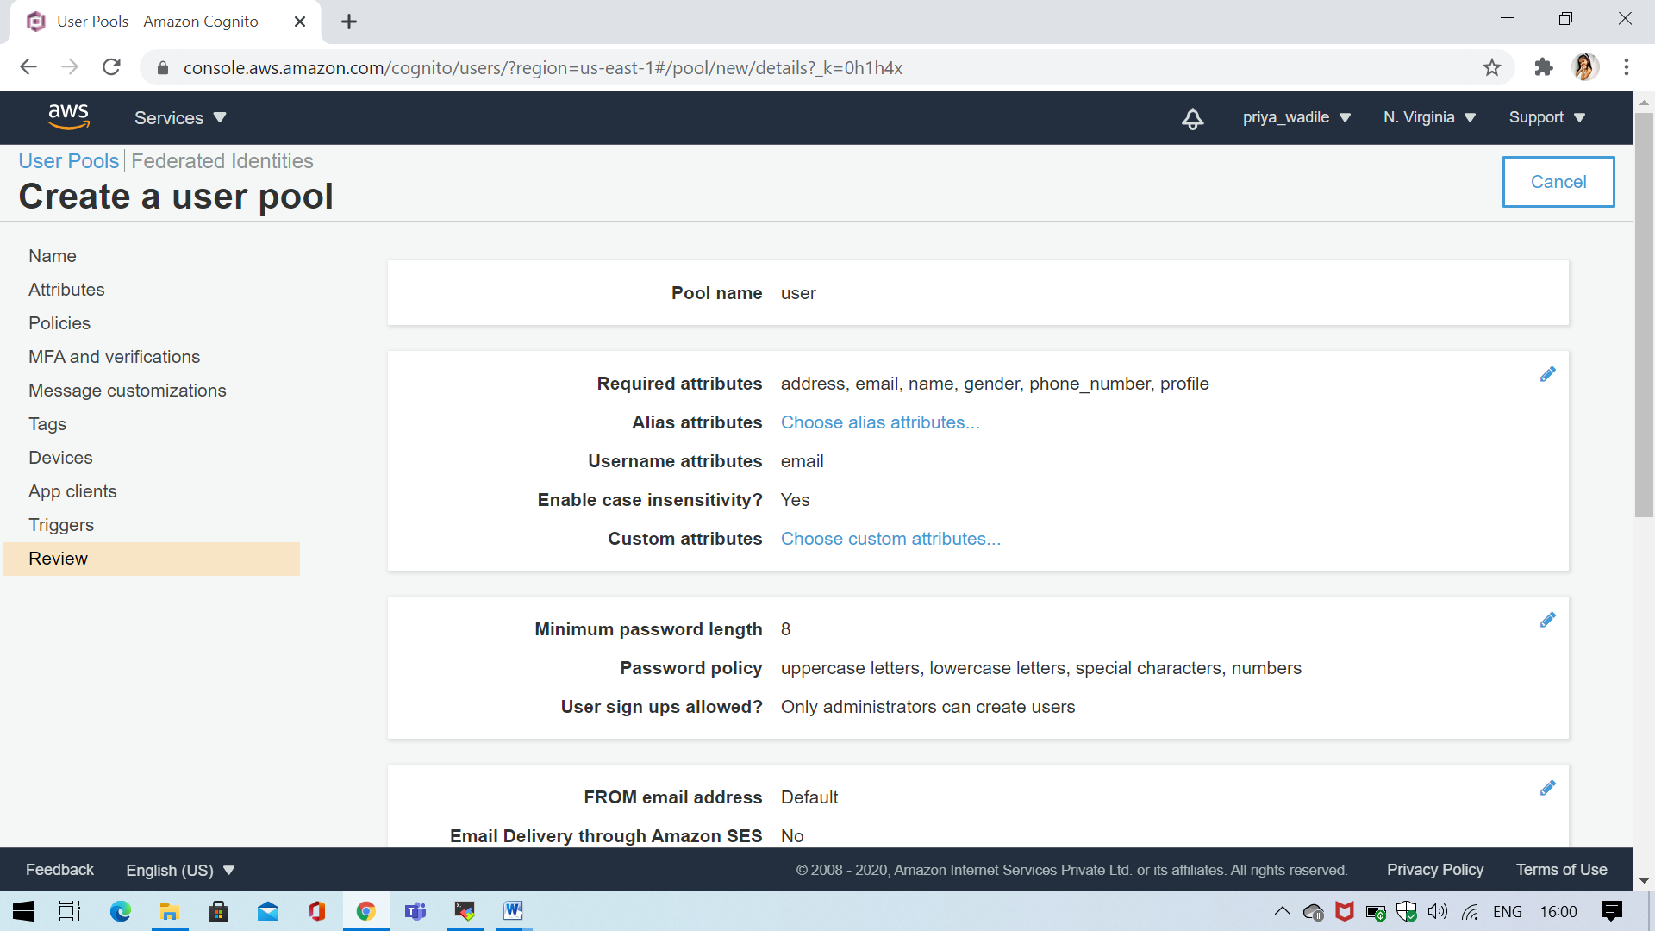

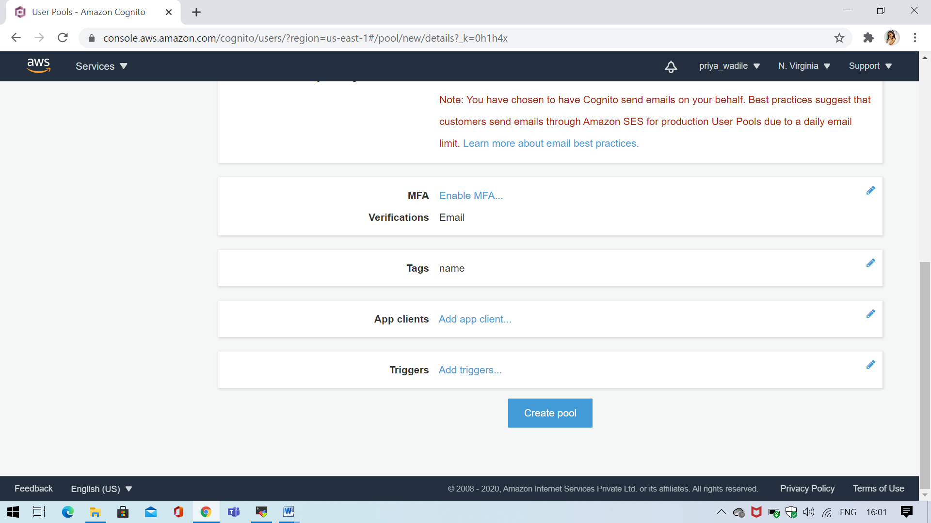

Ss7: Successfully user pool created

